Sponsorship & Partnership – 8th Annual Pride of Southside Homebrew Invitational

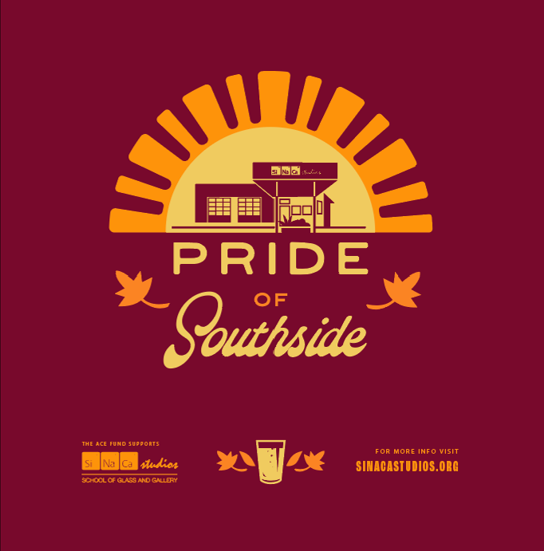
SiNaCa Studios presents our Pride of Southside Home Brew Invitational, a family friendly community fundraising event. Saturday November 2, 2024, from 12:00 until 6:00 at 1013 W. Magnolia Ave, Fort Worth TX
SiNaCa Studios is a 501(c)(3) nonprofit in Fort Worth’s Near Southside Arts cultural district that elevates glass art, provides public access and artists’ programs with gallery and studio space, as well as runs education and community outreach programming. At this event we celebrate the best in our community and raise funds to support our Artistic, Civic, and Educational Fund. The event includes a “Home Brew Competition” celebrating the best in local craft brewers and Live Music celebrating the best in local young musicians!

Reach
Email Contact List: 13,798 | Facebook Followers: 20,216 | Instagram Followers: 2,573
Signage on location on walkable Magnolia Avenue in the Near Southside Arts Cultural District
All sponsors recognized at partnership level pre-event during our October email newsletter, October “Facebook Live” virtual presentation, and event related social media posts on Facebook and Instagram.
Partnership and Sponsorship Opportunities
Funding Match: $1,000 level, $2,500 level, or $5,000 level
Help us reach our $20,000 goal through a funding match. Make a tax-deductible philanthropic gift matching our event fundraising dollar for dollar at chosen level. Named with gratitude or remain publicly anonymous.
Sponsorship Levels
Presenting Sponsor: $1,000
Largest logo on event collateral, tee shirt, and general signage at event. Includes 2 glass beer mugs, 2 event tee shirts, and inclusion on exclusive Brewers judging panel.
Music Sponsor: $500
Signage at stage. 2nd size logo on event collateral and tee shirt. Incudes 2 glass beer mugs & 2 event tee shirts.
Local Brewers Sponsor: $250
Signage at local brewers’ tables. 2nd size logo on event collateral and tee shirt. Includes 2 event tee shirts.

Our Home Brew Competition highlights local craft brewers and consist of two awards! “Best in Show – People’s Choice” Award & “Best in Show – Professional Brewers Choice” Award, judged by panel of professional local brewers.

Contact Clifton Crofford to commit to your sponsorship level | clifton@sinacastudios.org | 817-287-1800 or
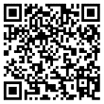
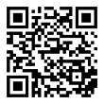
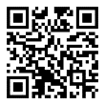
use a link or QR code to secure a DONATION, a SPONSORSHIP, or EVENT TICKETS with a Credit Card payment.

